 CHEMICAL ENGINEERING TRANSACTIONS  VOL. , 2025 | A publication of  
The Italian Association
of Chemical Engineering
Online at www.cetjournal.it

Guest Editors: Laura Piazza, Francesco Donsì, Giorgia Spigno
Copyright © 2025, AIDIC Servizi S.r.l.
ISBN 979-12-81206-19-9; ISSN 2283-9216
Numerical modeling of Ohmic heating of heterogeneous food
Angela De Vivoª , Ferruh Erdogdu^{b}, Fabrizio Sarghiniª*

ªUniversità degli Studi di Napoli Federico II Dipartimento di Agraria, via Università 100 – 80055 Portici (NA) – Italia
^{b}Ankara University, Dept. Food Engineering , Golbası Kampusu Golbası-Ankara - 06830 Turkey
*fabrizio.sarghini@unina.it

Ohmic heating is a promising thermal processing technique in the food industry, as it offers rapid, uniform heating by passing an electrical current directly through the food product. However, food materials often exhibit heterogeneous structures—composed of regions with different conductivities, varied moisture levels, and complex geometrical features—which can result in non-uniform temperature distributions and pose challenges for process control. This study aims to develop and validate a comprehensive numerical modelling approach to predict the heating behaviour in heterogeneous food systems subjected to ohmic heating.
A coupled multi-physics framework is used to simulate both the electrical and thermal phenomena. The governing equations for electric field distribution (based on current continuity and Ohm’s law) and transient heat transfer (using the standard heat conduction equation) are solved simultaneously. Temperature-dependent electrical conductivity and heat capacity are incorporated to capture the dynamic variations of material properties during the heating process. Additionally, geometric complexities—including solid particles, convection effects and varying product matrices—are represented in the simulation to emulate real-world food products.
The numerical results highlight the formation of localized hotspots in regions with higher electrical conductivity, as well as cooler zones in lower-conductivity regions. Numerical analyses reveal that factors such as voltage gradient, particle size and distribution, and flow behaviour (if any) can significantly influence the final temperature profiles.
Validation against experimental data demonstrates good agreement, suggesting that the proposed modelling approach can serve as a reliable tool for process design and optimization. This work provides valuable insights into how heterogeneity affects thermal treatment outcomes and offers guidance for developing robust ohmic heating modelling to support efficient process scale-up.
  - Introduction
Ohmic heating (also known as electrical resistance heating) is a process wherein electric current is passed through a food material to generate internal heat due to its electrical resistance. The heating is governed by Joule’s law, where the volumetric heat generation rate is given by Q = σE², with σ being the electrical conductivity and E the electric field strength. This approach offers a distinct advantage over conventional thermal processing by ensuring rapid and uniform heating, particularly beneficial for heat-sensitive and high-viscosity products.
The efficacy of ohmic heating strongly depends on the electrical conductivity of the food, which is often temperature-dependent and varies with composition (e.g., water, salt, fat content). Additionally, foods with non-uniform structures such as particulates suspended in a liquid matrix introduce complexities due to variations in thermal and electrical properties. In real-world applications, foods are rarely homogeneous. Systems such as soups, stews, or fruit preparations consist of multiple phases — solid particulates within a liquid carrier — and each phase may exhibit distinct electrical and thermal properties. These heterogeneities can lead to uneven heating, where certain regions heat up faster than others, creating "hot spots" or "cold zones" which can compromise safety and quality.
Early studies on ohmic heating primarily focused on homogeneous liquids (Sastry and Barach, 1995). As industrial interest grew, research shifted toward understanding heating behaviour in multiphase and particulate-laden systems. Sastry and Li (1996) investigated liquid-particulate mixtures heating and found that particle size and conductivity heterogeneities between liquid and particulate play major roles in temperature distribution.
  - Methodology
    - Numerical modelling
Models must couple the electrical potential distribution (governed by Laplace’s or Poisson’s equation) with the transient heat conduction equation, including the heat generation term due to ohmic dissipation. The presence of materials with different conductivities necessitates mesh refinement at interfaces and careful treatment of boundary conditions.Some research has introduced multi-physics modeling, incorporating aspects like fluid flow, microbial inactivation kinetics, and phase change (Jittanit et al., 2010). However, full-scale industrial models for irregular, real food products remain scarce. Most studies use idealized geometries or simplified assumptions. There is a clear need for high-fidelity, experimentally validated models tailored to industrial processing scenarios.The global set of governing equations is the following:
    - Electrical Field Equation (Laplace Equation)
Ohmic heating relies on the passage of electrical current through food, generating heat due to electrical resistance.
$∇ · \left(σ\left(\vec{x}, T\right)∇φ\right)= 0$ (1)
Where:
σ(𝑥, T): electrical conductivity [S/m], varies with position and temperature
φ: electric potential [V]
x: spatial coordinate
    - Heat Generation (Joule Heating Term)
$Q\left(\vec{x}, T\right)= σ\left(\vec{x}, T\right)⋅{\left|∇φ\right|}^{2}$ (2)
This equation represents the volumetric heat source generated by the electrical current within the material.
    - Heat Transfer Equation (Energy Balance)
$ρ\left(\vec{x}\right){c_{p}\left(\vec{x}, T\right) \frac{∂T}{∂t}}_{}= ∇ · \left(k\left(\vec{x}, T\right)∇T\right)+ Q\left(\vec{x}, T\right)$ (3)
Where:
ρ: density [kg/m³]
cp: specific heat capacity [J/kg·K]
k: thermal conductivity [W/m·K]
T: temperature [K]
Q: volumetric heat source from ohmic heating [W/m³]
    - Multiphase Interface Conditions
At interfaces between distinct regions (e.g., solids in liquid):
$T_{\left\{solid\right\}}= T_{\left\{liquid\right\}}$ (4)
$k_{solid}∇T_{solid}⋅\vec{n}= k_{liquid}∇T_{liquid}⋅\vec{n}$ (5)
$φ_{solid}= φ_{liquid}, σ_{solid}∇φ_{solid}⋅\vec{n} = σ_{liquid}∇φ_{liquid}⋅\vec{n}$ (6)

    - Boundary Conditions for the Electric Field
In ohmic heating applications, the boundary conditions (BCs) for the electric field are critical for accurately modeling the electrical potential distribution across the food domain. These conditions are typically applied at the electrodes and may vary depending on whether a steady-state or time-dependent analysis is conducted.
For steady-state simulations, a common approach is to apply constant voltage boundary conditions, often derived from the root mean square (RMS) value of an alternating current (AC) source. In this case, the potential is set as φ = ±V_RMS at opposing electrodes, and Neumann (zero-flux) boundary conditions are used at electrically insulated surfaces, i.e., ∂φ/∂n = 0. In time-dependent simulations, a sinusoidal voltage can be applied to represent the actual time-varying nature of the AC source. For instance, the potential can be modeled as
φ(t) = V₀ sin(2πft), (7)
where V₀ is the peak voltage and f is the frequency. This allows for more accurate representation of transient electric field behavior and heating dynamics, especially in systems where electrical properties are strongly temperature-dependent. Selection between RMS-based steady-state and time-varying BCs depends in theory on the required level of model fidelity and computational resources.
For many food processing applications, steady-state RMS values provide a sufficiently accurate approximation, while transient models may be necessary for detailed analyses or validation purposes. But of course, the use of time-varying BCs is much more demanding in terms of computational power, especially when high frequency power generators are used. The question is whether the use of RMS BCs changes the picture in terms of food heating, being the last one a phenomenon working at a slow characteristic times respect to the electric field. In order to test the effects of different BC in Ohmic heating modeling, an experimental setup was prepared for model validation, consisting in Ohmic heating of NaCl- water solution in a cylindrical OH chamber (Figure 1). Simulation were performed using Ansys Fluent 2022.
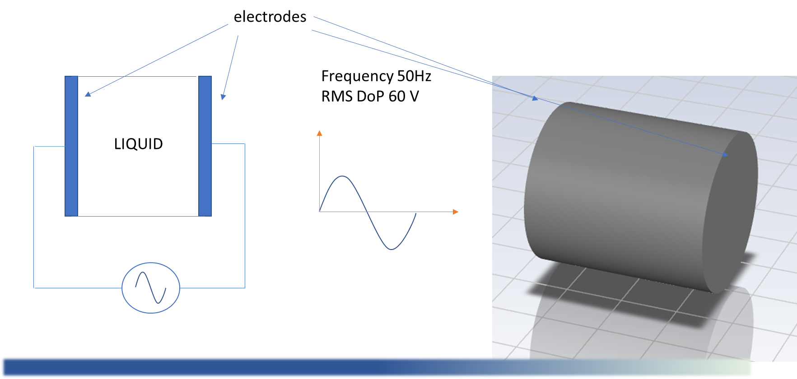
  - Figure 1 – Experimental setup for model validation of Ohmic heating.
  - Results
Electrical conductivity σ is a critical parameter in ohmic heating simulations and is strongly influenced by temperature, composition, and phase of the food material. In this work it was modeled as a linear function of temperature:
σ(T) = σ₀ (1 + α (T - T₀)) (8)
where σ₀ is the conductivity at a reference temperature T₀, and α is a material-specific constant.
Thermal conductivity k, specific heat Cp, and density ρ may also vary with temperature, especially in systems involving phase transitions or high moisture gradients. Accurate modeling requires experimental data or reliable empirical correlations for these properties.
Three different types of BC were tested:
- Unsteady 60V peak DoP (Difference of Potential) with 10 (DT1),100 (DT2) and 1000 (DT3) time steps per period
- Steady 60V DoP
- Assigned current flux (obtained experimentally)

Figure 2 - Validation of numerical model awith experimental data in a Ohmic chamber with 1% NaCl solution.
Results are shown in Figure 2, and they reflect a good agreement with experimental data only for the case of unsteady assigned BC, with negligible differences between 10 and 1000 time steps per period.
    - Effect of convection in heterogeneous system
Another important effect often neglected is related to internal convection inside the chamber. To highlight the importance of such effects, a numerical simulation was performed for the heterogeneous system composed by small carrots parts immersed in a 1% salty solution (Figure 3a)

a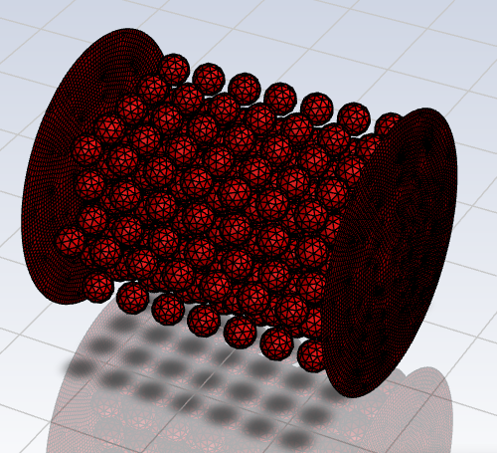 | b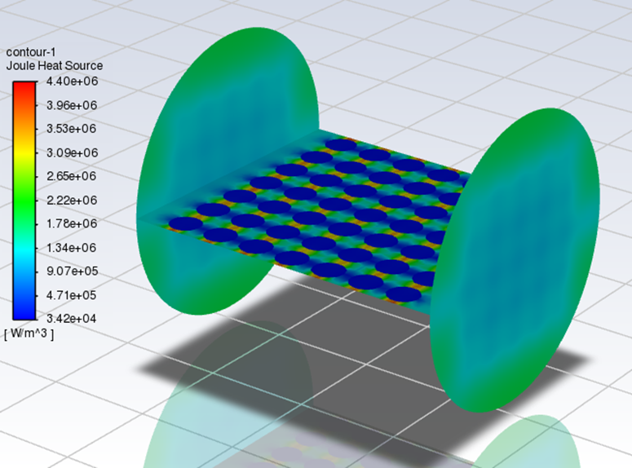
Figure 3 - Geometric configuration of the heterogeneous system (spherical carrots in solution) and distribution of energy sources on a normal plane
The Joule sources distribution on a cross section is reported in Fgure3b, showing a greater production of energy due to the Joule effect near the carrots.
As a consequence of this, due to the variation in density of the solution in which the solid parts are immersed, convective motions are generated with an ascending velocity in the internal area of the chamber and descending near the side walls (Figure 4a and 4b).

a | b
Figure 4 - Vector plot of the velocity field into two perpendicular sections of the heating chamber after 30 s.

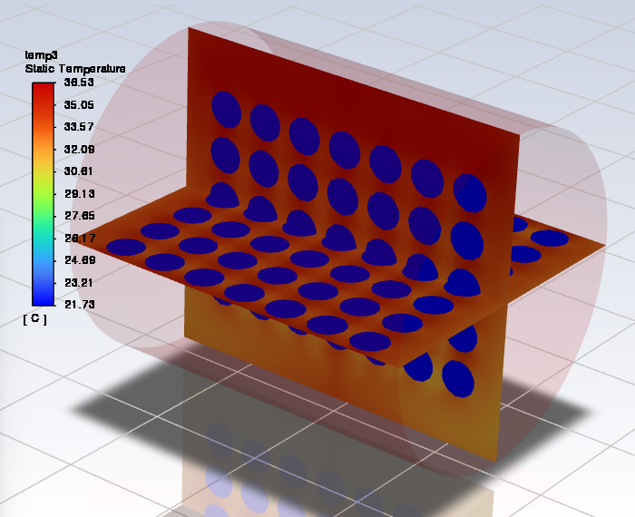

Figure 5 - Distribution of the internal temperature after 30s
In systems containing liquid phases, the density gradients induced by temperature differences lead to buoyancy-driven fluid motion (Figure 5). This natural convection results in the upward movement of warmer, less dense fluid and the downward sinking of cooler regions, establishing circulation patterns. Consequently, a consistent vertical stratification of temperature may occur, with the upper layers often reaching higher temperatures while the lower regions remain comparatively cooler. This phenomenon undermines the inherent advantage of ohmic heating as a volumetric method, introducing spatial non-uniformity in thermal distribution. Such stratification is particularly critical when the heating profile must be tightly controlled to ensure product safety, quality, or regulatory compliance. Ignoring this effect in simulation models may lead to an underestimation of cold spots and an overestimation of process efficiency.

  - Conclusions
The accurate application of boundary conditions plays a pivotal role in the numerical simulation of ohmic heating processes, particularly when dealing with heterogeneous food matrices. Since both the electric field and the resulting heat distribution are strongly influenced by the nature and placement of boundary constraints, inappropriate or oversimplified conditions can lead to significant deviations from real-world behavior. Electric field boundary conditions—whether defined in terms of steady-state RMS values or time-dependent waveforms—directly govern the distribution of current and thus the spatial pattern of heat generation. Similarly, thermal boundary conditions control how heat escapes or accumulates at the system boundaries, influencing both transient and steady-state temperature profiles within the food. Incorporating realistic, geometry-specific, and possibly time-varying boundary conditions enhances the predictive capability of simulation models, making them more suitable for optimization, control, and design of industrial ohmic heating systems. Therefore, special attention must be paid to the definition and implementation of boundary conditions when developing or interpreting numerical models for ohmic heating applications in food engineering. In the modeling of ohmic heating processes, particularly in heterogeneous food systems, the accurate representation of convective motion is essential to predict realistic temperature distributions. Although ohmic heating is primarily driven by internal heat generation through electrical resistance, the presence of fluid phases within the system—such as brine, juice, or other aqueous components—introduces convective heat transfer phenomena that can significantly alter thermal gradients. Natural or forced convection can enhance heat redistribution, especially in regions of high temperature or low viscosity, and thus influence the overall heating uniformity. This is particularly relevant in scenarios where solid particles are suspended in a conductive liquid medium, as fluid movement around these inclusions can lead to localized hot or cold spots that affect product quality and safety. Neglecting convective contributions may lead to underestimation of heating rates in fluid zones or overestimation in stagnant regions. Therefore, integrating convection modeling—either by coupling energy equations with momentum equations (e.g., Navier-Stokes) or by applying empirical convection-enhanced conductivity factors—can improve the fidelity of simulations. This is especially critical when designing industrial-scale equipment or optimizing process parameters for complex multiphase food systems.
References

Ruan, R., Ye, X., Chen, P., & Doona, C. (2001). Ohmic heating: A review. Journal of Food Process Engineering, 24(2), 91–108.
Haghighat Khajavi, S., Haddadnia, A., & Kenari, R. E. (2014). Modeling of ohmic heating of a two-phase system. Heat and Mass Transfer, 50(8), 1081–1089.
Jittanit, W., Charoenrein, S., & Nathakaranakule, A. (2010). Ohmic heating-assisted drying of fruits and vegetables: A review. Drying Technology, 28(8), 986–996.
Nguyen, L. T., & Nguyen, M. H. (2013). Simulation of ohmic heating of a two-phase food product using finite element method. Journal of Food Engineering, 115(2), 241–249.
Sarang, S., Sastry, S. K., & Knipe, L. (2008). Electrical conductivity of fruits and meats during ohmic heating. Journal of Food Engineering, 87(3), 351–356.
Sastry, S. K., & Barach, J. T. (1995). Ohmic and inductive heating. Food Science and Technology International, 1(5), 405–415.
Sastry, S. K., & Li, Q. (1996). Modeling the ohmic heating of liquid–particulate mixtures. Food Research International, 29(5–6), 493–502.

